PHYS 212 PreLab 6 Name ______________ ID_____________________
Q1[8’] Make a sketch of the magnetic flux passing through the area of the loop as a function of the rotation angle θ on the axes of Figure 2.
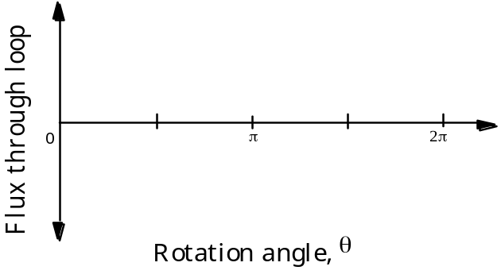
Figure 2. Flux through rotating loop in uniform magnetic field

Q2[8’] What are the kinetic energy and the speed of the magnet at the lowest point on the track?

Kinetic energy __________ [J]
Speed __________ [m/s]

Q3[8’] Make a sketch of flux through the loop as a function of the cart position as it moves from a to b then back to a on the axes of Figure 4. (Hint: the flux depends only on the magnetic field (always basically to the right) and the area vector of the loop (assume that is also pointing to the right).
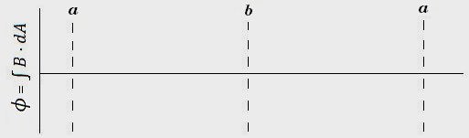
Figure 4. Flux through loop

Q4[8’] Make a sketch of the rate of change of flux through the loop as a function of the magnet position as it moves from a to b and back to a on the axes of Figure 5 based on your sketch in Figure 4.
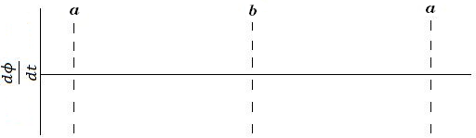
Figure 5. Rate of change of flux through loop

Let us put a bit of this together. As the flux changes through the surface defined by the loops, an EMF (Electromotive Force) is generated there. This is true even if there are no wires there! But because there are wire loops there, the electrons in the wire can respond to this EMF, generating a current in the wire. In principle, the induced current could be sufficient to light the bulb shown in Figure 3. Assume that it is.
Q5[8’] How many times does the bulb blink (i.e. turn on) over the course of three complete round trips?
___________________________________________________________
___________________________________________________________

Q6[5’] Where does the energy come from that lights the bulb?

___________________________________________________________
___________________________________________________________
Q7[5’] Continuing with the assumption that no friction exists, does the magnet reach the same peak height at the end of each return trip?[2’] Why?[3’]
___________________________________________________________
___________________________________________________________

In this lab you will be asked to determine the direction of induced currents. The easiest way to do this is to realize that induced currents create magnetic fields that oppose the motion of things causing a change in flux. For example, if you push a magnet into a coil, the induced currents will try to prevent the magnet from being pushed in. Similarly, if you pull a magnet out of a coil, the induced current will try to prevent the magnet from being pulled out.

